Brillion City Logo

**February 16 Spring Primary**

**Narrows down candidates for April ballot**

**2021 Spring Election-April 6th, 2021**

The 2021 Spring Election will be held on Tuesday, April 6, 2021 for Circuit Court Judges, Municipal Offices, and School District Offices, Superintendent of Department of Public Instruction

The following municipal officers for the City of Brillion are to be elected to succeed the present incumbents listed. The term of Alderperson At-Large begins on Tuesday, April 13, 2021 and is a three (3) year term unless otherwise indicated.

Mayor: Incumbent – Mel Edinger

Alderperson At-Large: Incumbent – Betty Nies

Alderperson At-Large: Incumbent – TJ Moehr-1 year term

We would like to remind all of you that should you find yourself in need, the Brillion Police Department does offer safe rides.

Snow is here for the season. A reminder that overnight parking is restricted for the snow season. If you need overnight parking for special circumstances, please call the department at (920) 756-2221. If Calumet County dispatch answers they will have a Brillion Officer contact you directly. You must call every time for overnight parking during the snow season parking rules.

Check the City of Brillion website for (ordinance) snow clearance requirements for sidewalks. Please give yourself more time to get to your destination, as slippery road conditions will be more prevalent. Allow for more distance between you and the vehicles in front of you.

Let us all make it to our destinations safely!

.

**Dog and Cat Licenses Due April 1**

All City of Brillion residents owning a cat or dog that is older than 6 months are required by City Ordinance to purchase a license. License for 2021 can be purchased at the City Clerk’s office between Dec. 15, 2020 and April 1, 2021.

License fees:

$3.00 spayed or neutered

$8.00 non-spayed or non-neutered

A $5.00 penalty will be imposed after April 1, 2021.

YOUR CITY OFFICIALS

Mayor

Mel Edinger, 756-3506

Alderpersons-At-Large

Betty Nies, 756-3952

Carrie Wenzel, 756-3008

Sarah Pielhop, 242-2025

Joe Levash, 418-3840

Joe Behnke, 418-2381

Tim Hanson, 418-5688

TJ Moehr, 418-0788

Municipal Court

Jean Van Frachen,

Municipal Court Judge

Joy Buboltz,

Municipal Court Clerk

CITY STAFF

City Hall …….……756-2250

Peter Wills,

City Administrator

Patty Schreiber,

Deputy Clerk-Treasurer

Jan Wittman,

Administrative Assistant

Police ….……....756-2221

Kirk Schend, Police Chief

DPW .……….….756-2250

Andrew Geiger,

Dir. of Public Works

Library …...........756-3215

Rachel Hitt, Director

Park & Rec….....756-3216

Ann Marx, Recreation Director

Fire Dept.…..,....756-2424

Joe Diener, Fire Chief

Building Inspection. 378-2857

Paul Birshbach, Building Inspector

**City Council Mission Statement**:

*Brillion…dedicated to being a great place to Live, Work, Learn, and Play - Together*

**Council Meetings**

If you are interested in attending a City Council meeting, please don’t hesitate to do so! All meetings are

open to the public. They are held the fourth Monday of the month at 6:30 pm at the Brillion Community Center.

The City Connection

QUARTERLY PUBLICATION OF THE CITY OF BRILLION

January 2021 – March 2021

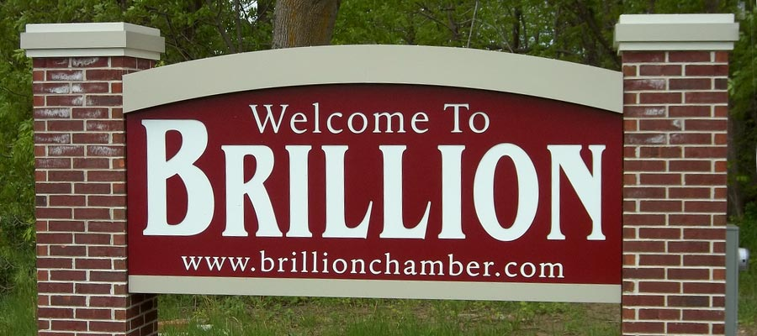

This Issue

Garbage & Recycling **P.1**

Library & Fire Dept. updates **P.2**

Community Center **P.3**

City Officials & City News **P.4**

2021 Recycling Schedule

**West of Main Street**

January 4, 17, 31

February 14, 28

March 14, 28

April 11, 25

May 9, 23

**East of Main Street**

January 10, 24

February 7, 21

March 7, 21

April 4, 18

May 2, 16, 31

Copies of the recycling schedule are available at Brillion City Hall or on the City’s website: www.ci.brillion.wi.us

City Hall Hours

Monday – Thursday

8:00 am – 4:30 pm

Friday 8:00 am – 12:00 pm

**Garbage and recycling cans should not be placed on the street. They should be placed by the curb Tuesday nights**. **Please do not put tires or electronics in your garbage, if you do, we will send you an invoice for these to cover our costs!**

**Parking Reminder**:

Parking is prohibited between the hours of 1am – 6am on any city street from November 15 – April 1

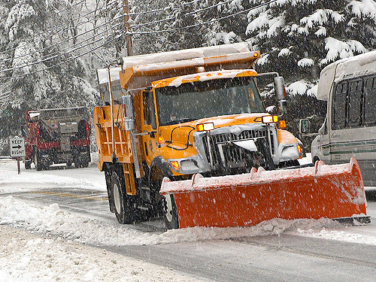

As a courtesy we ask people to keep parked vehicles off the street during the day, if possible, when it is snowing and the plow crews are out trying to clear the roadways.  This enables us to do a neat job the first time around.  We appreciate your assistance and cooperation!!

Recycling DOs and DON’Ts

Paper

**Accept:**

* Milk, Juice & Soup Cartons
* Cardboard & Paperboard (cereal box)
* Newspaper & inserts, Junk Mail & Office Paper
* Phone Books, Books, Magazines & Catalogs
* Shredded paper (put in brown paper bag & staple shut)

**Do NOT accept**:

* Tissue
* Paper contaminated by food or grease

*Guidelines: flatten and cut cardboard to no larger than 2’x2’*

**Accept:** All plastic bottles and containers:

* Soda, Water, & Other Drink Bottles
* Food & Household Bottles, Jars and Jugs
* Dairy Containers & Lids
* Produce Bakery & Deli Containers

**Do NOT accept:**

* Plastic Bags, Wrap, or Film
* Motor Oil Bottles, No Styrofoam

*Guidelines: remove all screw caps and discard, rinse bottles and jugs*

**Accept:**

* Aluminum Cans and Bottles
* Steel, Tin, and Bi-metal cans, Metal Lids
* Empty Aerosol Cans

**Do NOT accept:**

* Aluminum Pans or Foil, Empty Paint Cans

*Guidelines: rinse cans and bottles, no need to remove labels*

**Accept:**

* Food and Beverage Bottles and Jars

**Do NOT accept:**

Windows, Ceramics or China

*Guidelines: rinse bottles and jars, metal caps and lids should be recycled, discard plastic caps and lids.*

Plastic



Aluminum & Steel

2021 Garbage & Recycling Fees

The annual Garbage and Recycling User Fees for the City of Brillion residents will be applied to your 2020 Property Tax bills which are payable in 2021. This amount will be added to the first installment of the property tax bill and will be due by January 31, 2021. The 2021 user fees are:

45 gallon = $139

65 gallon = $144

95 gallon = $152

If you would like to change the size of your barrel, please contact City Hall at 756-2250.

Glass



Page 4



**Brillion Public Library Mission Statement:**

“The Brillion Public Library strives to improve the community life by providing free and equal access to information, ideas, and knowledge through books, programs, and other resources, and by preserving the local history.”

**BRILLION PUBLIC LIBRARY**

**“BOOKS n’ MORE”**

326 MAIN ST.

BRILLION WI 54110

**PHONE**

920-756-3215

**FAX**

920-756-3874

**E-MAIL** [brref@mcls.lib.wi.us](mailto:brref@mcls.lib.wi.us)

**WEB:** http://ci.brillion.wi.us/ departments/library

**LIBRARY HOURS**

**Tentative Schedule**

Monday-Thursday

12-7PM

Friday 12-6 PM

Saturday 9AM-12PM

Sunday -closed

Curbside service available

During these hours

Page 3

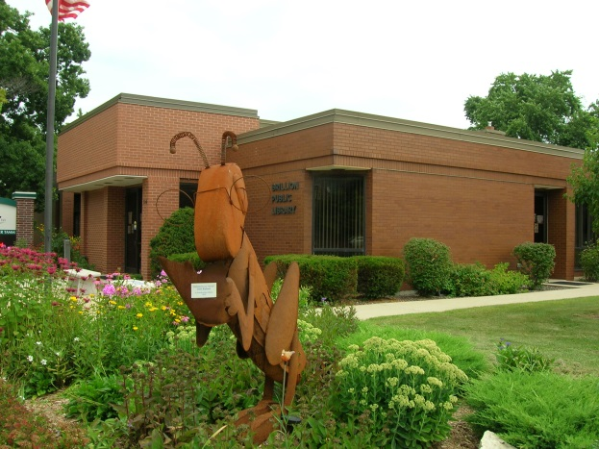

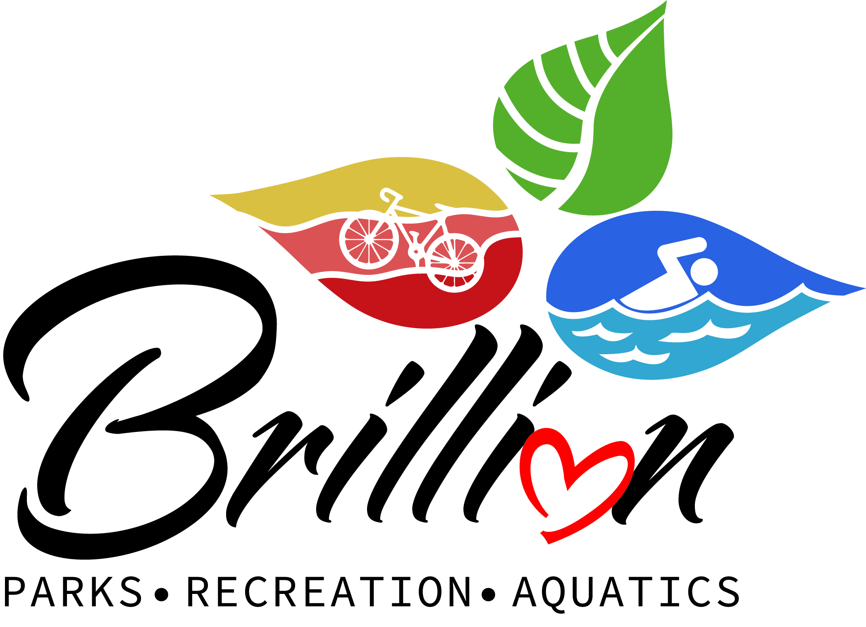

**Building Hours**

Monday 5:30am-8:00pm

Tuesday 9:00am-8:00pm

Wednesday 5:30am-8:00pm

Thursday 9:00am-8:00pm

Friday 5:30am-1:00pm

Saturday 8:00am-1:00pm

Sunday Closed

**SNOW REMOVAL POLICY**

Per City Code, any person failing to remove either snow or ice from the sidewalk within 24 hours after a snowfall or sleet storm shall be subject to forfeiture, and the city shall have such sidewalk cleared of snow or ice and the expense thereof levied as a special tax against the property, collected as are other taxes. The expense of such snow and ice removal shall be charged at a rate of $120.00 per hour plus administrative fees with a minimum charge for 1 hour.

* Please shovel your sidewalks within 24 hours after a snowfall.

* Please DO NOT blow or shovel snow back into or across the street

* Please do not pile snow on the sidewalk terrace if your property is in the Downtown District.

* Please keep your sidewalks & sidewalk ramps free of ice & snow.

* Please remove vehicles from the street when the snowplows are in operation.

* Please remove snow from around fire hydrants near your home.

All patrons are asked to limit their visit to the library to 30 minutes or less. We are asking library users to conduct their business quickly and treat their visit to the library as they would a trip to the grocery store. We are happy to choose materials in advance for you to review during your library visit. As much as it pains us, we are not encouraging collaboration, conversation, or lingering at the library at this time, and library meeting rooms are closed to the public.

We realize some may see these requirements as burdensome and maybe even unnecessary, but we believe that libraries hold a special place in the community. Libraries across the state and country recognize that the characteristics that make us special a free place for people of all ages to gather, linger, and learn—place library users, library staff, and our communities at risk during a pandemic. Public libraries, including Brillion Public Library, are committed to serving the public while striving to protect public health. We’ve based our services and mitigation measures on the data and research-based guidance of public health experts. As a result, we’re providing direct access to the building, materials, and services with measures in place to reduce the risks involved and to decrease the likelihood of disruptions to library services. We’re also providing new ways for you to experience the library at home through virtual Storytime, virtual book discussion groups, STEAM activity kits for checkout, and themed book bundles for DIY Storytime!

Thank you for your continued support!

The current, barring unforeseen circumstances, the library will reopen to the public on Monday, January 4th. Appointments are not required, but we do ask that families call ahead to confirm that we are not at capacity. Please check the library website or Facebook page for the latest information. Please continue to return all library materials to the outdoor book drop.

In order to keep our doors, open to the public and maintain our commitment to the health and safety of staff, library users, and the community, we will reopen with special limits and requirements in place. Ten people are allowed into the library at a time, and all visitors to the library age three and up are required to wear a mask or face covering that covers the mouth and nose at all times while inside the library. Those without a face covering will be provided one free of charge. Our face covering requirement was authorized by the library board and is independent of any statewide mask mandate and will continue even when state mask mandate ends for COVID.



**BCC NEW Winter**

**Building Hours**

Monday 5:30am-8:00pm

Tuesday 9:00am-8:00pm

Wednesday 5:30am-8:00pm

Thursday 9:00am-8:00pm

Friday 5:30am-1:00pm

Saturday 8:00am-1:00pm

Sunday Closed

**Brillion** C**ommunity Center**

120 Center St.

Brillion, WI 54110

Phone: 920-756-3216

**Register online at activityreg.com**

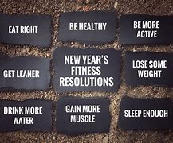

Fire Department Updates – from Fire Chief Joe Diener

http://www.clker.com/cliparts/q/w/S/H/j/R/red-flame-hi.png

There have been several questions brought up recently in regards to our Annual Brat Fry this year and if it will be taking place. The answer is Yes! We are excited to once again have it. Things will be a little different this year than in the past however. This year we want to make sure everyone remains safe, so we will be hosting a drive through event only, there will be no dining in. At this time, it will be the same Sunday as in the past, which will be February 7th, 2021. We are finalizing the logistics of the event, but we wanted to make sure you had plenty of notice that YES, it will be taking place!

Once we have all the final plans in place, we will be posting those on Facebook and the City website. As of now, all Brillion Fire Department members are selling our normal cash raffle tickets. We will not be having any side raffles this year, but we are working on doing another raffle the day of the event.

We want to say “Thank You” for all of your support in the past, and hope that you are remaining to stay healthy as we continue to make positive improvements with the COVID-19 pandemic. We hope that once again, you will be able to join us this year, just in a little different way. Again, once we have everything worked out, will update you on our Facebook page, and the City website.

Thank You, and be well,

Chief Joe Diener

**Hazardous Waste Disposal:**

Dates, times, and locations for hazardous waste drop off programs being held throughout Calumet County:

The city of Brillion is targeting September 2018 for a hazardous waste collection at the DPW garage. Stay tuned for updates.

Appointments are REQUIRED To make an appointment or for more information go to [www.calumetrecycles.com](http://www.calumetrecycles.com)[.](https://www.calumetrecycles.com)



Page 3

Page 2